


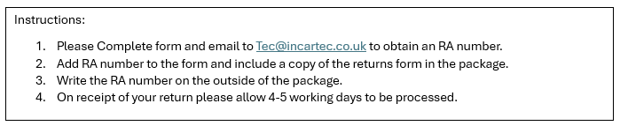
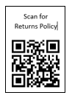
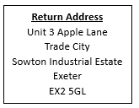

Name/Company |  | RA No. ______________ Date: _________
Email: |  | RA No. ______________ Date: _________
QTY | Stock code | Order No. | Order Date | Return  Code | Reason for return/Details of Fault | Car Year, Make & Model | Office Use
